**ENTERPRISE RESOURCE PLANNING**

1. **INTRODUCTION TO ERP**

**Enterprise Resource Planning (ERP)**

* Systems are the specific kind of enterprise systems to integrate data across and be comprehensive in supporting all the major functions of the organization.
* ERP is the use of shared computer systems across the business.

**Component**

Electricity (1st Layer)

* Degree of Availability

1. Sparse and unreliable.
2. Small scale and limited.
3. Widespread but inconsistent.
4. Ubiquitous but at a cost.

Hardware (2nd Layer)

* Technological Development

1. Rudimentary devices
2. Radios

Network (3rd Layer)

* Technological Development

1. Landlines
2. WiFi

Software (4th Layer)

* Technological Development

1. Processing capability
2. Analytic pragrams

Artificial intelligence (5th Layer)

* Technological Development

1. Machine Learning

**Introduction to Enterprise Systems for Management**

1. Hardware Infrastructure (1st Layer)
2. Operating System Components (2nd Layer)
3. Database (3rd Layer)
4. ERP (4th Layer)
5. User (5th Layer)

**Client-Server Architecture**

* Architecture of a computer network in which many clients (remote processors) request and receive service from a centralized server (host computer).
* It explains how computers talk to each other when they need something from the other.

**Hardware**

* A physical parts of a computer

**Hardware: A Computer**

* A machine that can store and process information.

**Software**

* Instructions that tell a computer what to do.

**Peopleware**

* The ‘human’ component of a computer system.

**Microsoft**

* Dynamics 365.

**Oracle/Peoplesoft**

* Fusion Cloud ERP.

**SAP**

* SAP ERP.

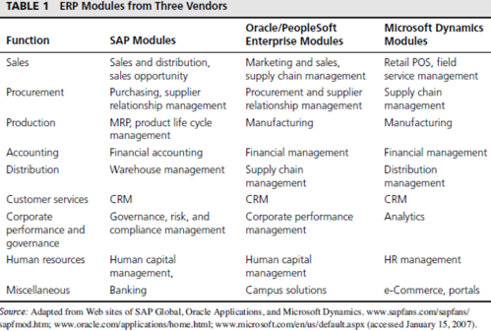

**SAP**

* Is the industry leader in ERP systems.
* Has over 40 years of enterprise resource planning experience across industries and business sizes.
* SAP: Systemanalyse Programmentwicklung.
* Founded in 1972.
* Is modernly known today as SAP SE.

**SAP ERP**

* SAP ERP is an enterprise resource planning software developed by the German Company SAP SE.

**SAP S/4HANA Cloud**

* A future-ready enterprise resource planning (ERP) system with built-in intelligent technologies, including AI, machine learning, and advanced analytics.
* This version of SAP uses Cloud Technology and Data Analytics coupled with Low Code Environment

**Production Module**

* Helps in planning and optimizing the manufacturing capacity, parts, components, and material resources using historical production data and sales forecasting.

**Purchasing Module**

* Streamlines the procurement process of required raw materials and other supplies

**Inventory Management Module**

* Facilitates the processes of maintaining the appropriate level of stock in a warehouse

**Sales and Marketing Module**

* Implements functions of order placement, order scheduling, shipping, and invoicing.

**Finance Module**

* Is the core of many ERP software systems
* Gather financial data from various functional departments and generate valuable financial reports.
* e.g. budgets, balance sheet, general ledger, trail balance, and quarterly financial statements

**Human Resource Module**

* Streamlines the management of human resources and human capital

**Miscellaneous Modules**

* **Business intelligence**
* It uses business analytics, data mining, data visualization, and data tools to help organizations make better data-driven decisions.
* **Self-service**
* The users with appropriate permissions can register themselves in the system and use the applications in the Self-Service modules to create records without the assistance of an administrator or a service desk agent.
* **Project management**
* It considers the role of project management as a core driver for managing and delivering successful projects.
* **E-commerce**
* It covers the main concepts of e-commerce and develops an understanding of how to set up, manage and maintain a store on an online platform, a social media platform and an e-commerce marketplace.

1. **ERP IN MANAGEMENT**

**Architecture**

* Must be conceived after the selection of ERP software
* Usually, the architecture is conceived before buying or developing software in other IT implementations

**Logical**

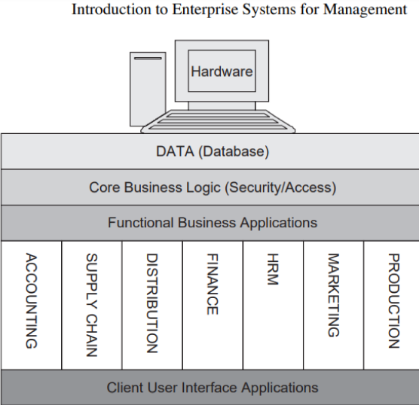

1. Lowest tier: Database Schema of Entities and Relationships
2. Second tier: Core Business Processes and Business Logic
3. Third tier: Provides details on the applications that support the various business functions built in to the ERP system

**Physical**

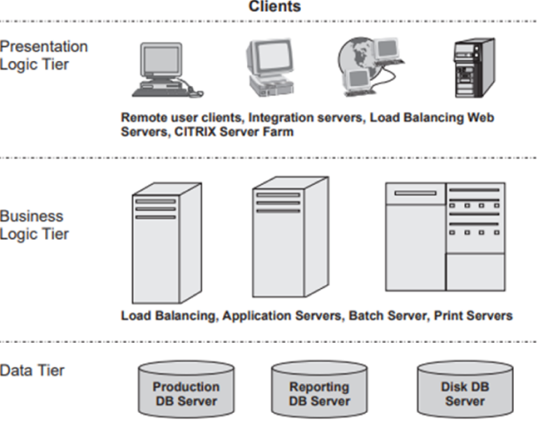

**Business Process Management**

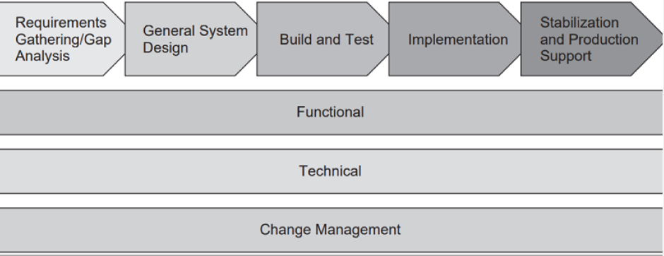

* Is the understanding, visibility, and control of business processes

**ERP Lifecycle**

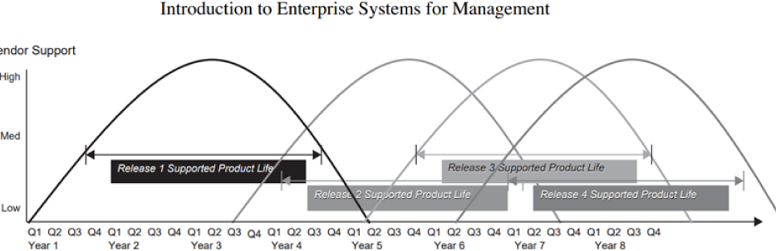

**Chocolate**

* An implementation with considerable modifications to the ERP software package
* Increase the chances of success with the users
* Modifications increase the investment in the system and introduce higher implementation risk

**Vanilla**

* Are minimally modified (or as-is)

**Benefits and Limitations of ERP**

* Require investment in terms of cost, time, and people

**Benefits of ERP**

* Integration of data and applications across functional areas of the organizational
* This positively affects security, consistency of inputs, ease of maintenance, and efficiency

**Limitations of ERP**

* Complexity of installing, configuring, and maintaining the system increases, thereby requiring specialized IT staff, hardware. Network, and software resources
* Corporate white-collar crimes such as questionable accounting and marketing practices, privacy violations, unauthorized data sharing, spam mail, viruses, snooping, phishing, and identity theft

**Functional Silos**

* Are basically compartmentalized operating units isolated from their environment

**Horizontal Silos**

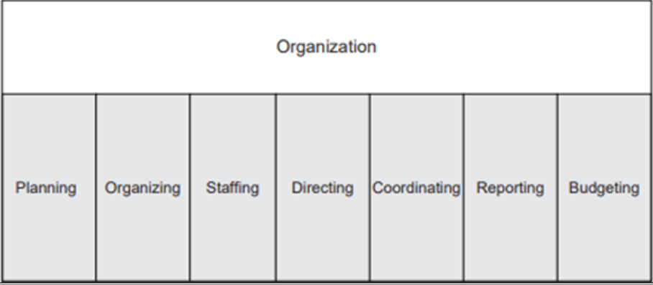

**Vertical Silos**

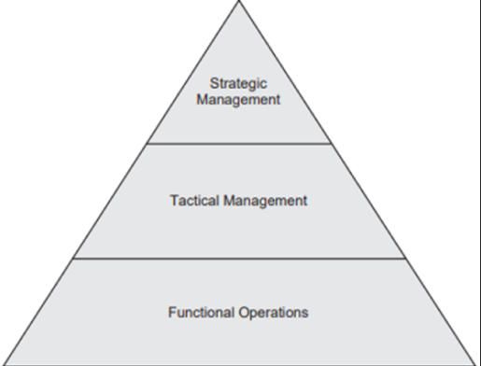

1. **ERP IN GAME THEORY**

**Game Theory**

* Is the study of the ways in which interacting choices of agents produce outcomes with respect to the preferences of those agents, where the outcomes in question might have been intended by none of the agents
* Is the study of the consequences of your actions
* Introduced Von Neumman & Morgenstern (1944)

**Game**

* All situations in which at least one agent can only act to maximize their utility through anticipation the responses to his actions by one or more other agents.
* Where a player tries to predict the effects of their actions against or with another player

**Player**

* Agents involved in games

**The Prisonners’s Dilemma**

* Suppose that the police have arrested two people whom they know have committed an armed robbery together/ Unfortunately, they lack enough admissible evidence to get a jury to convict.
* They do, however, have enough evidence to send each prisoner away for two years for theft of the getaway car.
* The chief inspector now makes the following offer to each prisoner:
* If you will confess to the robbery, implicating your partner, and they do not also confess, then you’ll go free and they’ll get ten years. If neither of you confess, then you’ll each get two years for the auto theft

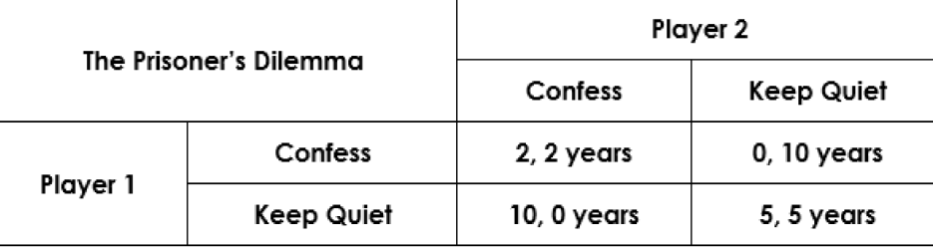

**Analytics**

* Is field of computer science that uses math, statistics, and machine learning to find meaningful learning to find the meaningful patterns in data

**Descriptive Analytics**

* Presents its findings using reports, pivot tables, and visualization like:
* Histograms
* Line graphs
* Pie charts
* And, box and whisker plots
* Why it did happen
* Focus on root cause and effect (root cause analysis)
* It aims to identify and explain anomalies and outliers

**Predictive Analytics**

* What might happen in the future
* Uses deep learning, machine learning algorithm to find patterns

**Prescriptive Analytics**

* What should do next?
* “the future of data analytics”

**Business Analytics**

* Is analytics applied to business data

**Short-Term Data Collection**

* Barely allows researchers to develop a deep understanding of participants’ characteristics, experiences, and beliefs

**Long-Term Data Collection**

* Dropout rate is high

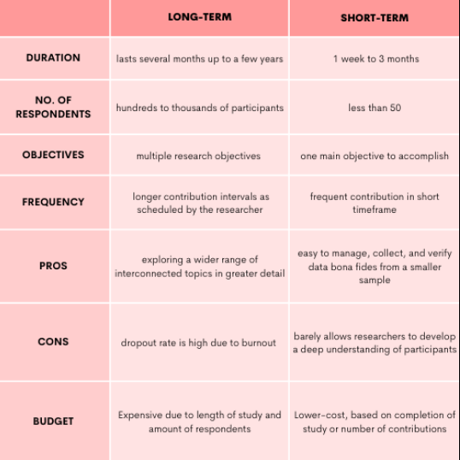

**Marketing and Sales**

* Inputs:
* Customer data
* Order data
* Sales trend data
* Per-unit cost
* Company travel expense policy
* Outputs:
* Sales strategies
* Product pricing
* Employment needs

**Supply Chain Management**

* Inputs:
* Product sales data
* Production plans
* Inventory levels
* Layoff and recall company policy
* Outputs:
* Raw material orders
* Packaging orders
* Resource expenditure data
* Production and inventory reports
* Hiring information

**Accounting and Finance**

* Inputs:
* Payments from customers
* Accounts receivable data
* Accounts payable data
* Sales data
* Production and inventory data
* Payroll and expense data
* Outputs:
* Payments to suppliers
* Financial reports
* Customer credit data

**Human Resources**

* Inputs:
* Personnel forecast
* Skills data
* Outputs:
* Regulation compliance
* Employee training and certification
* Skills database
* Employee evaluation and compensation

1. **MARKETING AND SALES**

**Sale**

* The exchange of a commodity for money
* The action of selling something

**Marketing**

* The activity or business of promoting and selling products or services
* Includes market research and advertising

**Presale Activities**

* Customers can get pricing information about the company’s products
* An **inquiry or a sales quotation**
* Include marketing activities such as tracking customer contacts – including sales calls, visits, and mailing.
* Enhances targeted marketing efforts

**Sales Order Processing**

* Series of activities that must take place to record a sales order
* Can start from a **quotation or inquiry**
* Any information that was collected from the customer to support the quotation (contact name, address, phone number) is immediately included
* Include recording the items to be purchased, determining the selling price, and recording the order quantities
* Can use product-specific pricing, such as establishing quantity discounts for a particular item
* SAP ERP system checks the accounts receivable tables in the SAP ERP database to confirm the customer’s available credit

**Inventory Sourcing**

* SAP ERP system checks the company’s inventory records and the production planning records to see whether the requested material is available and can be delivered on the date the customer desires
* This **available-to-promise (ATP)** check includes the expected shipping time, taking into account weekends and holidays
* Availability is automatically checked, and the system can recommend an increase in planned production if a shortfall is expected
* Also keeps a record of all open orders, so even if product for a particular order is still in the warehouse, the system will not allow it to be sold to another customer

**Delivery**

* Creating a delivery means releasing the documents that the warehouse uses to pick, pack, and ship orders.
* Consider a policy of either **FOB Destination or Shipping Point**
* Process allows deliveries to be created so the warehouse and shipping activities are carried out efficiently
* Once the system has created the documents for picking, packing, and shipping, the documents are transferred to the Materials Management Module, where the warehouse activities of picking, packing, and shipping are carried out.

**Billing**

* Creates an **invoice** by copying the sales order data into the invoice document
* Accounting can print this document and mail it, fax it, or transmit it electronically to the customer
* Accounting records are also updated at this point

**Payment**

* Timely record of this transaction has an effect on the timeliness and accuracy of any credit checks for the customer
* If the payment is made electronically, it can be automatically processed by the SAP ERP system, which records the payment as an electronic sales order document
* If the customer sends a check, a clerk must manually enter the payment information, at which point the system updates all information related to the sale

**SAP Modules Involved**

1. **Sales and Distribution (SD)**

* To record prices, sales, and the delivery

1. **Customer Relationship Management (CRM)**

* To record customer information

1. **Controlling (CO)**

* Tracks the costs associated with producing products

1. **Human Capital Management (HCM)**

* Also termed as “SuccessFactors”
* Is responsible for Human Resource Management

1. **Production Planning (PP)**

* Forecast inventory and production

1. **Investment Management (IM)**

* To maintain stock and update stock level

1. **Supply** **Chain Management (SCM)**

* To take note of delivery status

1. **Customer Service (CS)**

* To take care of any concerns after delivery

1. **Enterprise Performance Management (EPM)**

* To produce figures on status of company